Software Testing Revision Questions 2017
Part I -Theory Questions

“The objective of software testing is all about finding software faults”. Can you list and explain 5 categories of software faults?

Explain any three of the following types of software faults:

- Documentation faults
- Stress or overload faults
- Throughput or performance faults
- Recovery faults
- Syntax Faults

What advantages does incremental software testing over the Big Bang approach (i.e. testing all at once)?

‘The classification of failures is more difficult than faults. One approach is to classify a failure by its level on a severity scale’ Give an outline description of a scale that has four different levels of Failure Severity.

Describe three approaches to Debugging software.

Briefly explain the differences between Unit, Integration, System and Acceptance testing.

Can software be tested exhaustively?

Deciding when the testing of a piece of software should finish can be difficult to judge. Can you suggest two different criteria or benchmarks that could be useful to a Software Testing manager when making that decision?

Describe the differences between static and dynamic testing.

Explain three differences between Black-box testing and White-box testing.

Using an example, show what the difference is between an Error of Commission and Error of Omission as they can occur in Black and White box testing respectively.
Define the following two terms and say which one is associated with Black box testing and which with White box testing.

- Errors of Commission
and
- Errors of Omission

Then, identify one example of each error in the specification and program code below:

Specification: the program return variable rv will return true only when the input value x is zero, otherwise it will be false.

public static boolean isZero(int x)
{
boolean rv=true;
if (x>=0)
rv=false;
else if (x<-1)
rv=false;
return rv;
}

What is Fault insertion testing? Detail five types of mutations that can be applied to software code.

What is the relationship between Equivalence Partitioning and Boundary value analysis?

Under which circumstances is Combinational testing using Truth Tables useful?

What is a control flow graph (CFGs)? Draw sample CFGs illustrating their appearance for a Switch statement and a While loop.

Explain the difference between the concept of using a ‘data-flow’ approach for creating a white-box software testing method in comparison to methods that are derived from using a CFG.

A ‘data-flow’ approach to testing is a way of looking at a program as a flow of data from one statement to another. The motivation is to find data flow anomalies. Give explanations of three types of anomalies with short examples.

Give one of the strengths and one of the weaknesses of five of the following White-box and Black-box software testing methods:

- Statement Testing
- Branch Testing
- Path Testing
- Equivalence Partitioning
- Boundary Value analysis
- Combinational Testing/Truth tables/Cause-Effect Graphing

State the difference between Software verification and Software validation in the context of software testing.

Explain two problems associated with software testing within the traditional Waterfall software process model.

“The V-model of software development emphasizes the verification and validation of software throughout the development process”. With the aid of an appropriate illustration, can you show and describe how this process is carried out at the various test stages from Unit testing through to Acceptance testing?

Can you discuss the advantages and disadvantages of using the V-model for software development?

The Incremental development model of Software Development is an ‘Agile’ method. Draw a diagram that illustrates how the Incremental development model works. Give one advantage and one disadvantage of it.

For the SCRUM approach to managing software development explain the following two terms. Also, sketch a diagram to show their relationship to each other.
  - Product Backlog
  - Sprint and Sprint Backlog

Explain one difference between the techniques of ‘Extreme Programming’ and Scrum.

Give one advantage and one disadvantage of the DevOps method of Software development. Briefly explain how DevOps differs from other techniques.

Part II - Practical Testing – Black Box Testing

Consider the following program specifications. Create the test cases and test data for the Black box test techniques of Equivalence Partitioning and Combinational Testing.

ComputeInsurance()
A program ComputeInsurance is used by an airline company to automatically assess the level of insurance the customer must pay on their ticket. Each customer can bring one piece of sports equipment and one piece of musical equipment on a flight:
If they bring both sports and music equipment the insurance is €20
If they only bring one piece of equipment only then the insurance is €10
If they bring no equipment then the insurance fee is €5
The program input consists of two boolean variables:
(1) sportsEquipment (2)musicEquipment
The program output is a single variable: insurance

PremiumWithoutMarried()
This program ‘CarIns’ assesses the cost of a car insurance policy. It takes three inputs of
age, gender and marital status. If the age entered is less than 16 or greater than 65 the
program returns a premium of zero. The input for gender takes the form of ‘M’ for male
and ‘F’ for female. If an incorrect value for the gender is entered the program returns a
premium of zero. In general a premium is €500. However, if a person is male, under 25
and not married then an extra €1500 is added to the premium. If the person is female and
married the premium falls by €200, and if the person is aged between 45 and 65 inclusive
the premium falls by €100.

railTicket()
A program for rail ticketing returns the level of discount available depending on the age of the traveler that is input: Children under 5 travel free; Children and young adults between the ages of 5 and 16 inclusive receive a 50% discount; those aged 65 and over get a 25% discount. An entry of less than 1 year and greater than 110 years is incorrect and the discount value returned is -1% to reflect the error. In all cases the age must be input as an integer value.

MartialArtsClub()
The specification for a program that computes the appropriate membership fee for a martial arts club is given below. The fee is based on the age of the member only. Membership is not allowed to ages outside the range of 6 to 65.

If the age of the member is from 6 to 18 the Membership fee is €100.
If the age of the member is from 18 to 40 the Membership fee is €200.
If the age of the member is from 40 to 65 the Membership fee is €180.

The program input consists of 1 parameter: int age. The program output is the memberFee value in Euros.

Any invalid input returns a fee of €0. Invalid input is when an age is out of range.

concertTicket()
The specification for a program that computes the ticket cost of a concert at a particular venue is given below. The fee is based on the age of the attendee and their membership status. People outside the age range of 18 to 50 are not allowed to buy a ticket.

If the age of the member is from 18 to 35 the ticket cost is €40 if they are not a member and it is €35 if they are a member
If the age of the member is from 36 to 50 the ticket cost is €65 if they are not a member and it is €55 if they are a member.

The program input consists of 2 parameters: int age and boolean isMember. The program output is the int ticketCost value in Euros. Any invalid input returns a value of -€1.

Grade()
The program Grade combines an exam and coursework mark into a single grade. The values for exam and coursework are integers. If the exam or coursework mark is less than 50% then the grade returned is a ‘Fail’. To pass the course with a ‘Pass, C’, the student must score between 50% and 60% in the exam, and at least 50% in the coursework. They will pass the course with ‘Pass, B’, if they score over 60% in the exam and 50% in the coursework. In addition to this, if the average of the exam and the coursework is at least 70%, then they are awarded a ‘Pass, A’. Input values that are less than 0 or greater than 100 for either the exam or coursework are invalid and the program will return a message to say ‘Marks out of range’.

StoreDiscounts()
A store in city offers different discounts depending on the purchases made by the individual. In order to test the software program that calculates the discounts, it is possible to identify the “price range” of purchase values that earn the different discounts. For example, if a purchase is in the price range of €1 up to and including €50 it has no discounts, a purchase in the price range of over €50 and up to €200 has a 5% discount, and purchases of price range €201 and up to €500 have a 10% discounts, and purchases of price range €501 to €2500 have 15% discounts. No items are sold outside these price ranges and if an incorrect price is entered the software returns a discount value of -1% to indicate that an error case has occurred.

Part III - Practical Testing – White Box Testing

Consider the following program code example. Create the test cases and test data for the White box test techniques of (a) Statement Testing, (b) Branch Testing and (c) Path Testing. To make the test cases for each program you must produce a Control Flow Graph (CFG).

TaxRelief() | 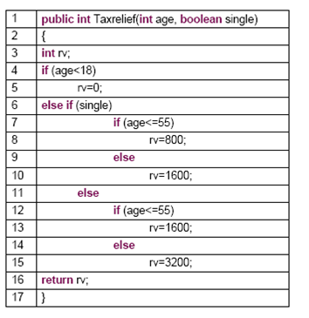

MemberFee() | 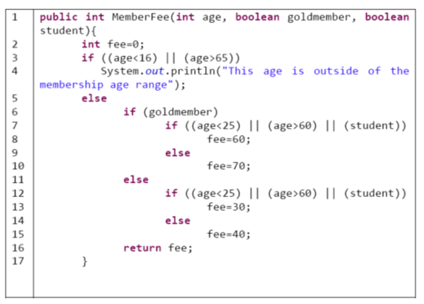

PhoneIns() | 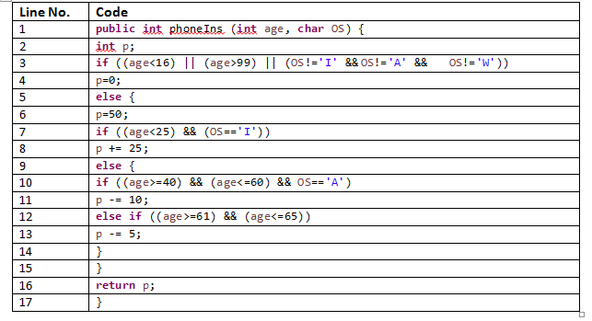

ComputeInsurance() | 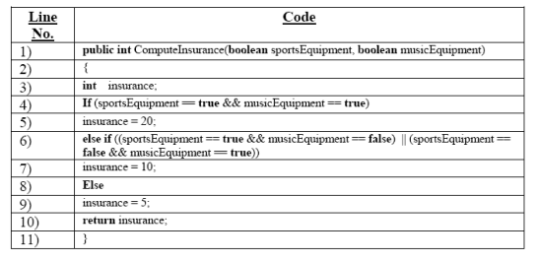

ComputeDiscount() | 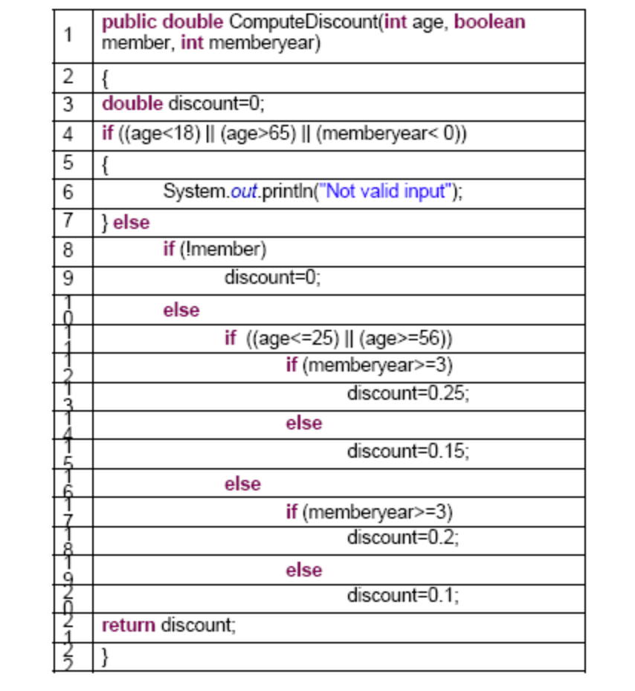

Grade() | 